**Experiment Title.**

**Student Name: Rahul Maurya UID:20BCS7260**

**Branch: CSE Section/Group: 716 B**

**Semester: 3rd Date of Performance:16/3/2022**

**Subject Name: MPI LAB Subject Code:** **20CSP-253**

1. **Aim/Overview of the practical:**

Finding 1’s and 2’s complement of 8 bit numbers using 8085

1. **Description/ Code:**

**1’s Complement**

#Begin 000H

LDA 5000H

CMA

STA 5001H

#ORG 5000 HLT

#DB 82

**2’s Complement**

#Begin 000H

LDA 5000H

CMA

INR A

STA 5001H

#ORG 5000 HLT

#DB 82

1. **Result/Output/Writing Summary:**

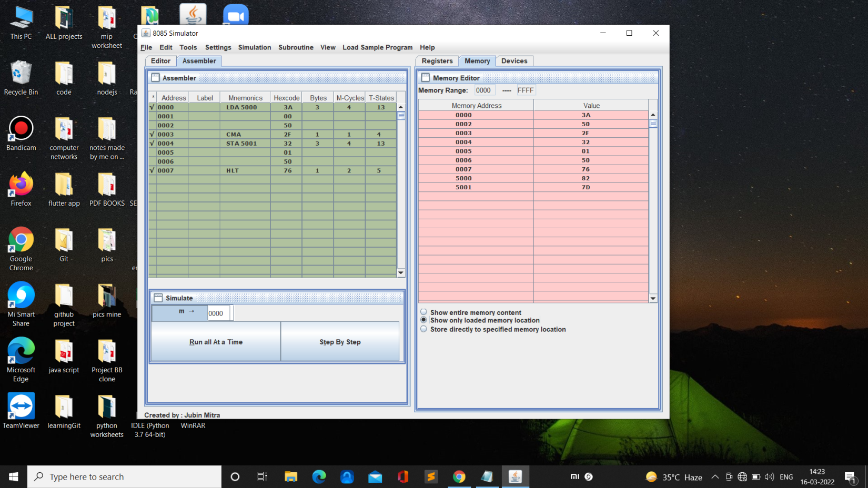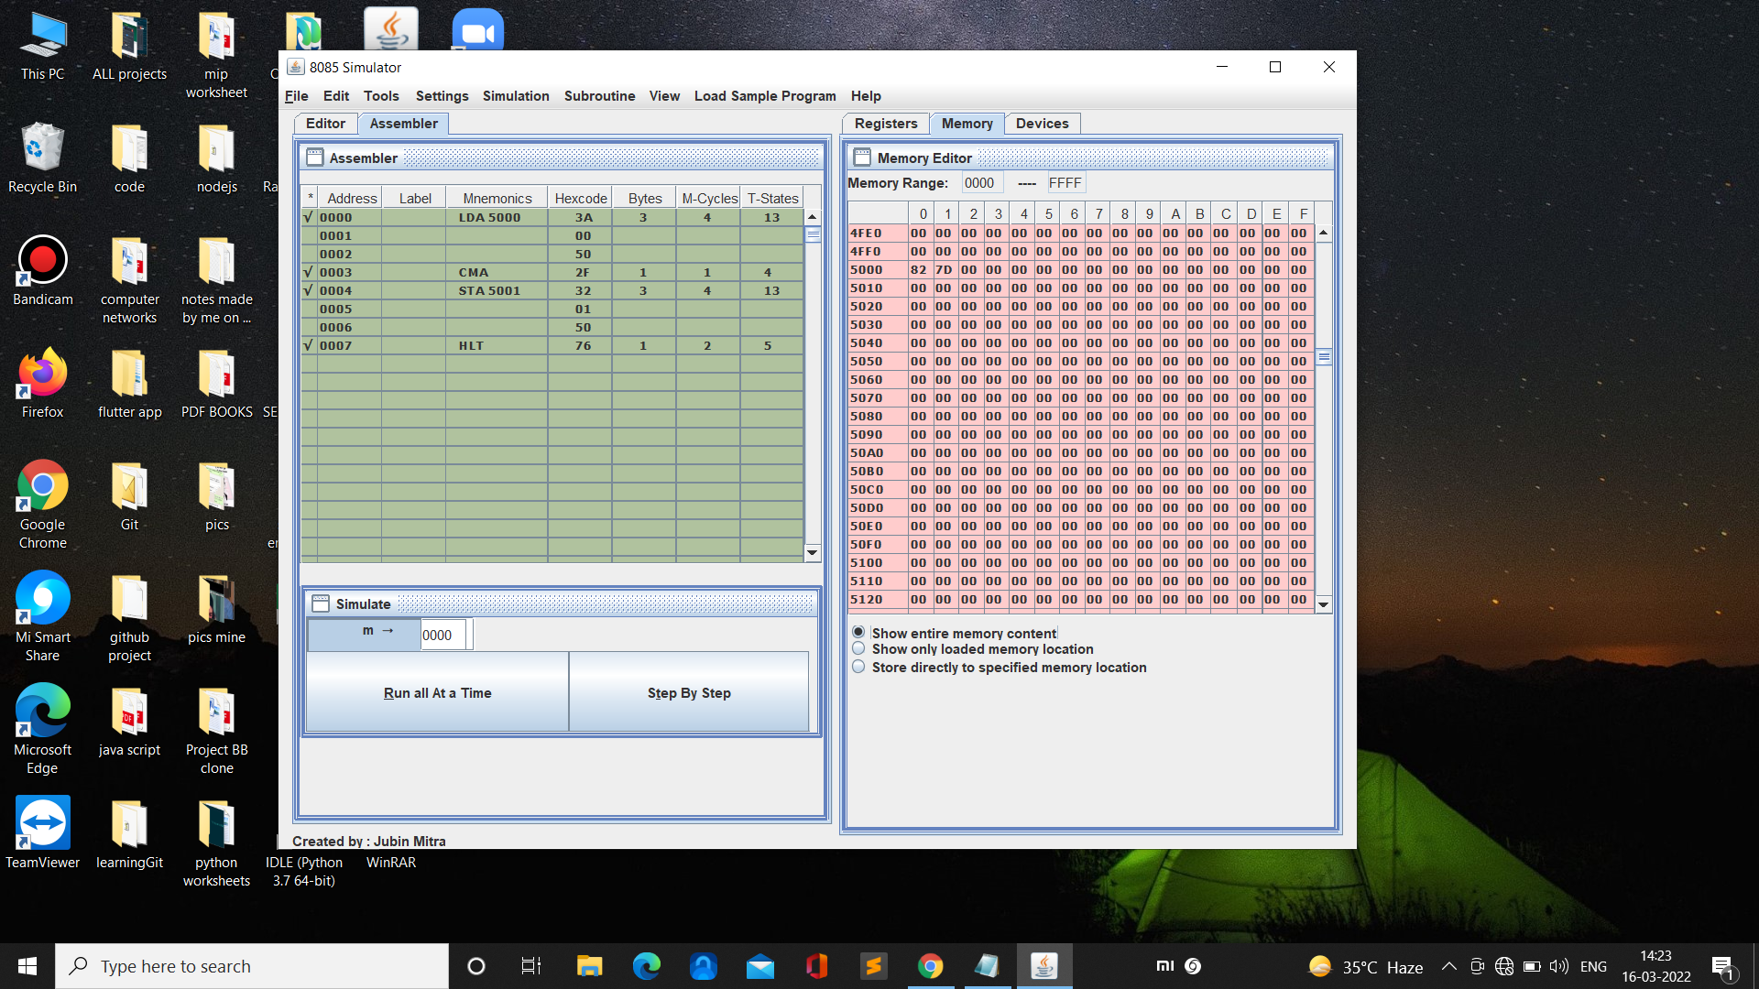

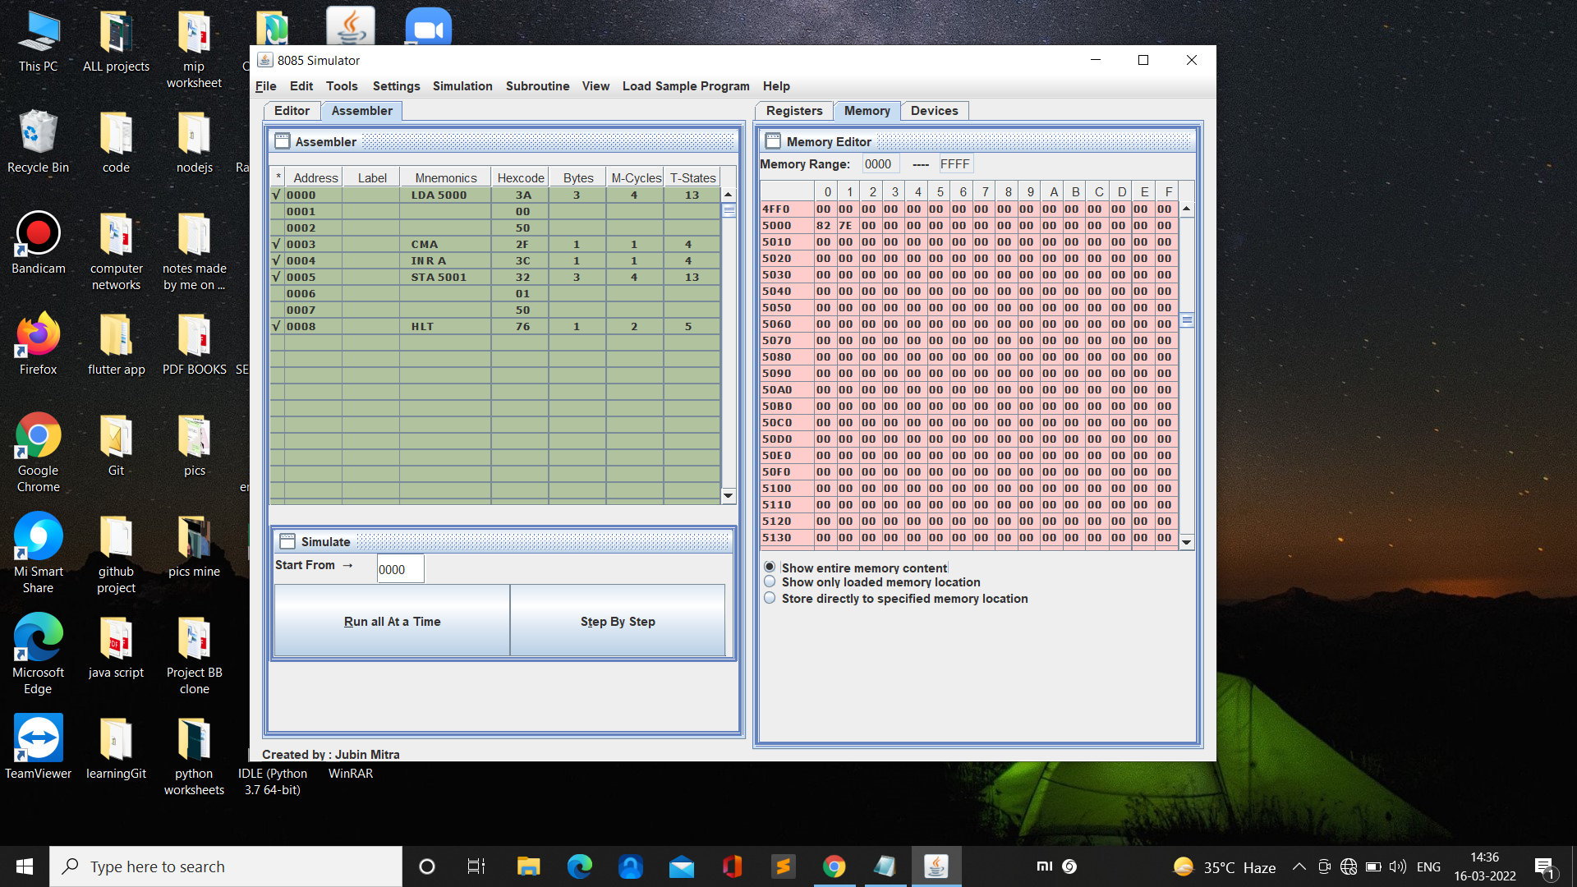**2’s complement**

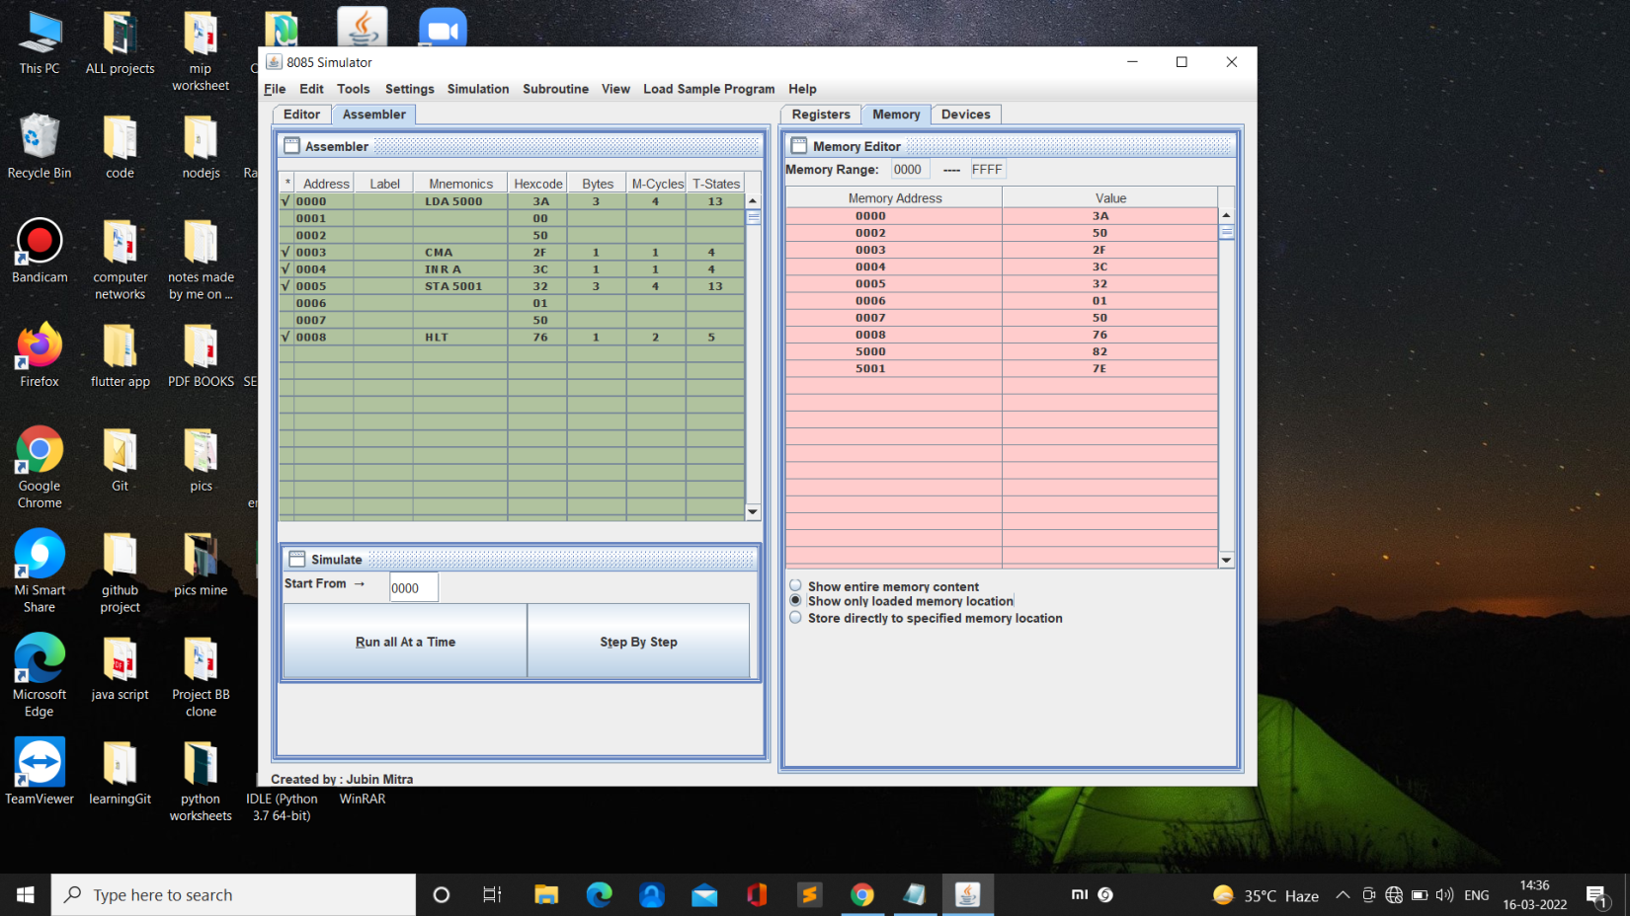

**Learning outcomes (What I have learnt):**

**1. I learnt about hex numbers**

**2. I learnt about finding 1’s complement of 8 bit numbers**

**3. I learnt about finding 2’s complement of 8 bit numbers**

**Evaluation Grid (To be created as per the SOP and Assessment guidelines by the faculty):**

|  |  |  |  |
| --- | --- | --- | --- |
| Sr. No. | Parameters | Marks Obtained | Maximum Marks |
| 1. |  |  |  |
| 2. |  |  |  |
| 3. |  |  |  |
|  |  |  |  |